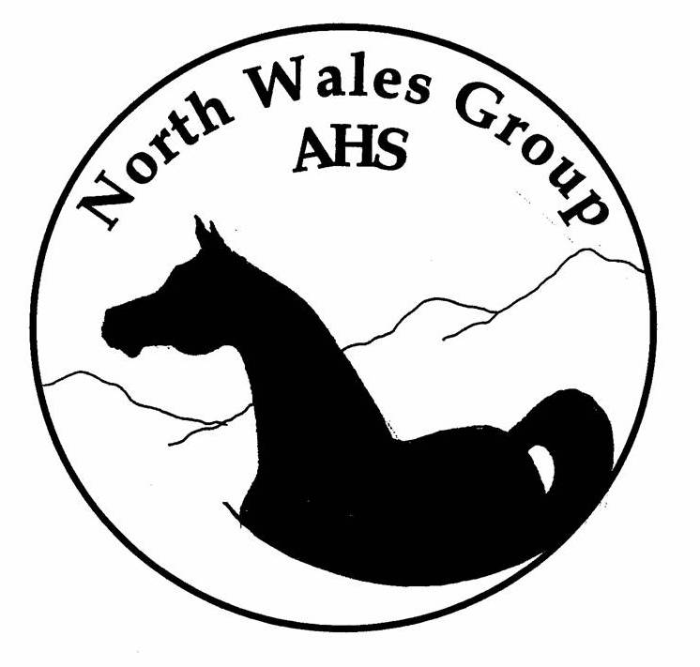

SUMMER SHOW - SUNDAY 16th AUGUST 2009
@ WELSH COLLEGE OF HORTICULTURE
EQUINE UNIT, HOLYWELL RD, NORTHOP
Jct 33A off A55 : Postcode: CH7 6AA

CHERIF, BAC, BAHPAC ’09
CRABBET & MIDLAND JNRS ’10
QUALIFIERS
COLOURED, CRABBET & EGYPTIAN CLASSES
CLASSIC HEAD CLASS

Entries Close 1st August ‘09
No Late Postal Entries
Show Day entries accepted ONLY with relevant fee and proof of registration for AHS classes – these entries will not be catalogued

Entry Secretary: Sue Walmsley
Lindley Cottage - 9 Hawthorn Crescent
Formby, Liverpool, Merseyside L37 4JF
Tel: 01704 834436

Enquiries to: www.northwalesarab.co.uk laura@northwalesarab.co.uk
Affiliation No: 14/03/104

JUDGES: IN HAND: Mr. N. Arnold
RIDDEN: Mrs. P. Hollings
SPECIAL: Mrs. M. Arnold

Entry Fees:
Members £6 per Non Members £8 per (before the closing date) Members £12 per Non Members £15 per (on show day*)
* double fee for 1st entry only – subsequent entries will be charged at pre-entry rate

First Aid Cap £2 per exhibitor

RULES RELATING TO NORTHOP SHOWS

- The committee and officials accept no responsibility whatsoever for loss, injury or damage to any person or their property whilst on the show ground.
- Exhibitors will indemnify the organisers and committee for any losses and claims arising. Exhibitors are advised to have suitable third party insurance. This is covered by some society membership, e.g. AHS, BHS.
- Horses must be kept under control at all times. Colts / Stallions 3 years and over must be bitted.
- All entries in affiliated classes must be registered with the Arab Horse Society, by the closing date for entries, except foals. A photocopy of the registration certificate must accompany the entry form. Partbred & Anglo entries minimum 12.5% arab blood, proven by AHS registration.
- Exhibits which appear late (missing the walk around the ring) will be excluded from the class. They will not be allowed in the ring after the first horse has been called into line.
- The judge's decision is final, and no dispute will be entered into.
- The committee reserves the right to amalgamate, divide, cancel or alter any class should it be deemed necessary.
- All ridden entries must be 4 years or over and all riders must wear protective head wear at all times when mounted. Junior riders (under 21) must wear PAS015 Standard Headwear with correctly fitting fastened harness.
- Stallions and colts may only be handled by a suitably competent person, over the age of 16 years. Ridden stallions must be ridden by a person over the age of 16, unless agreed with committee prior to show day.
- Trophies are perpetual and will be presented after completion of judging. A deposit of £10 is required for all trophies. Trophy winners must sign for the trophy and agree to return the cups at least 6 weeks prior to the next annual show. Failure to comply with returning the trophy incurs a fine of £25 in addition to the cost of a replacement, and further entries may be refused.
- Dogs must be kept on a lead at all times, and if causing disturbance will be asked to leave.
- Arab Horse Society rules for the conduct of shows will apply to this show. Exhibitors should make themselves aware of the current regulations concerning metal framed/wire cored show bridles, cruelty, mounting blocks, etc.
- Acceptance of these rules is a condition of entry under the show rules and regulations of the Arab Horse Society.
- A NOVICE ridden horse is one that has not won a total of three AHS novice classes prior to 1st Jan 2009, and who has never qualified for HoYS. Please check amended AHS Novice ruling
- Horses entered in the Pre-novice classes will not be ridden by the judge and will not be eligible
for any other AHS ridden class, or the AHS ridden championship.
16. Spurs may not be used in pre-novice and novice ridden classes. Whips in ridden classes may
not exceed 75cm in length. No junior riders to wear spurs.
17. Respect the college grounds – no mucking out of trailers / lorries onto the parking area.
18. The college entrance will be opened at 8am. No access before this time.
19. Limited stabling may be available by prior private arrangement with the college. Please contact them directly on 01352 841 054
20. None of the facilities are available for exhibitors without permission from the yard manager at the college

NOTE: ‘OUTSIDE ASSISTANCE’ OF ANY SORT WILL NOT BE TOLERATED. EXHIBITORS WILL BE ASKED TO LEAVE THE RING SHOULD THE JUDGES, STEWARDS OR COMMITTEE DEEM IS NECESSARY

NORTH WALES GROUP AHS – SUMMER SHOW QUALIFIER STATUS

- This is a qualifier show for the CHERIF CHAMPIONSHIP 2009. The final will be held at the Cherif Championship Show, Addington Manor Equestrian Centre, Addington, Bucks, on Wednesday 16th September 2009. All details and qualifying cards at £18.00 each (payable to the Cherif Championship) from Miss L. Temple, The Stables, Ashton Gifford Lane, Codford, Wiltshire, BA12 0JX. Tel: 01985 850 784. Please state the name, accurate height of horse/pony. SAE please.

CLASSES 6 & 7 Entries to be judged as Riding Horse. Ponies of 148cm and under are not ridden by the judge at any Cherif Championships qualifying show, but will give an individual show. These ponies will be ridden by a lightweight adult at the final. The highest placed entry within the first four in each class will qualify.

- This show is also a qualifier for the BAC and BAHPAC championships. The finals for these will be held on Saturday 5th & Sunday 6th September 2009 at Bromyard EC, Herefordshire.

‘Amateurs’ are to wear a yellow armband to make themselves known to the stewards.
NOTE: BAHPAC qualification is awarded to the 2 highest placed amateurs in each open AHS class. The AOBGAmateur classes (classes 15 & 16) in the Open Ring will not qualify.

Amateur / Home Produced Definition:

- Handler not to have been paid for showing or producing any horse for a 3rd party; this includes any remuneration either as employment, casual showing, or any ‘in- kind benefits’ whatsoever.
- Horse not to have "resided" on a professional yard on show / training livery in 2009.
- Horse not to have been shown by a professional in 2009.
- Horse not to have received "regular" training from a visiting professional in 2008.
Exhibitors DO NOT have to be members of AHS to enter the Championships when qualified.

Contact: Sally Etchells Tel: 0161 6653192 or E-mail: zalkym@hotmail.com
Cards are £10 each – SAE payable to ‘BAHPAC’ to:
8 All Saints Close, Royton, Oldham, Lancs, OL2 5RD

NOTE: Qualifying cards are to be presented for signing in the ring and it is the responsibility of the exhibitor to ensure that qualifications are correctly authorised.

- This show is a qualifier for the National Crabbet Championships 2010. First 2 unqualified horses will qualify, down to 2 places from bottom.

NOTE: Horses must be shown in a natural manner; the pose must be natural, i.e. forefeet together, hind feet slightly split. Head should show the natural arch and curve of throatline – muzzle to be in line with a point in line with 6 – 8 inches below wither. Horses should stand quietly in this position with an expression of interest towards handler. Any unnatural posing, flicking of whip, or circling on the trot out will (at judge’s discretion) result in horse being penalised as though no presentation/display had been made.

- This show is a qualifier for the Midland Group Junior Riders 2010

! Attention all North Wales Group Members !
Don’t forget to get your Sheila Rae Points Award forms signed

AHS RIDDEN CLASSES - commencing 9.00 am in indoor arena
Note: Rules 8, 9, 14, 15 & 16 in particular relate to ridden classes

CLASS 1 NOVICE PUREBRED MARE

CLASS 2 NOVICE PUREBRED STALLION OR GELDING

CLASS 3 NOVICE ANGLO OR PARTBRED - Stallion, Mare or Gelding

CLASS 4 OPEN PUREBRED MARE

CLASS 5 OPEN PURE BRED STALLION OR GELDING

CLASS 6 OPEN ANGLO OR PART BRED - 148cm & Under
Stallion, Mare or Gelding

CLASS 7 OPEN ANGLO OR PART BRED - Over 148cm
Stallion, Mare or Gelding

CLASS 8 RIDDEN VETERAN - Over 15 Yrs - Purebred, Anglo or Partbred Arab

CLASS 9 YOUNG RIDERS 16 Yrs & under - Purebred, Anglo or Partbred Arab

CLASS 10 YOUNG RIDERS 16 Yrs to 21 Yrs - Purebred, Anglo or Partbred Arab

**AHS RIDDEN CHAMPIONSHIP ‘A’ **
1st & 2nd from classes 1 to 7 inclusive are eligible – NWAG Trophy

OPEN CLASSES – to commence at 1.00 pm in the outdoor arena

- Marlak Stud Kindly Sponsor:

CLASS 11 JUNIOR COLOURED – colt, filly or gelding
Minimum 12.5% Arab blood

CLASS 12 SENIOR COLOURED – stallion, mare or gelding
Minimum 12.5% Arab blood

- LMA Arabians Kindly Sponsor:

CLASS 13 JUNIOR EGYPTIAN – purebred colt, filly or gelding
Minimum 75% Egyptian

CLASS 14 SENIOR EGYPTIAN – purebred stallion, mare or gelding
Minimum 75% Egyptian

- Arab Owners & Breeders Group Kindly Sponsor:

CLASS 15 PURE BRED AMATEUR HANDLER / HOME PRODUCED
Stallion, Mare or Gelding, Any Age

CLASS 16 ANGLO / PART BRED AMATEUR HANDLER / HOME PRODUCED
Stallion, Mare or Gelding, Any Age

CLASS 17 JUNIOR HANDLERS 21 YRS & UNDER
Pure, Anglo or Partbred Mare or Gelding

CLASS 18 PUREBRED, ANGLO OR PARTBRED VETERAN OVER 15 YRS

CLASS 19 CLASSIC HEAD – any age
The Mair Arnold / Black Bridge Arabians Award to most classic head

**AMATEUR CHAMPIONSHIP ‘B’ **
1st & 2nd from classes 15 & 16 are eligible – NWAG Trophy

**OPEN CHAMPIONSHIP ‘C’ **
1st & 2nd from classes 11 to 19 inclusive are eligible - Wood View & Maybella Trophy

AHS PUREBRED IN-HAND – commencing 1.30pm in indoor arena

CLASS 20 YEARLING - Colt, Filly or Gelding

CLASS 21 2 YEARS OLD - Colt, Filly or Gelding

CLASS 22 3 YEARS OLD - Colt, Filly or Gelding

CLASS 23 OPEN MARE - 4 yrs old & over
23A Special Award to Best Foal

CLASS 24 OPEN GELDING - 4 yrs old & over

CLASS 25 STALLION - 4 yrs old & over
Stardom Trophy awarded to best stallion

CLASS 26 VETERAN – Over 15 Yrs – Stallion, Mare or Gelding

- Lyndale Arabians (Texas) Kindly Sponsor:

CLASS 27 JUNIOR CRABBET – minimum 75%, verified by Crabbet Org
0 to 3yrs colt, filly or gelding

- Ivy Arabians Kindly Sponsor:

CLASS 28 SENIOR CRABBET - minimum 75%, verified by Crabbet Org
4yrs & over, stallion, mare or gelding

** AHS JUNIOR PUREBRED IN-HAND CHAMPIONSHIP ‘D’ **
1st & 2nd from classes 20 to 22, & 23A are eligible – NWAG Trophy

** AHS SENIOR PUREBRED IN-HAND CHAMPIONSHIP ‘E’ **
1st & 2nd from classes 23 to 28 are eligible – NWAG Trophy

AHS ANGLO & PARTBRED IN HAND To follow purebreds in indoor arena
(Minimum 12.5 % Arab blood)

CLASS 29 YEARLING - Colt, Filly or Gelding

CLASS 30 2 & 3 YEAR OLDS - Colt, Filly or Gelding

CLASS 31 OPEN BROOD MARE 4 yrs & Over
31A Special Award to Best Foal

CLASS 32 STALLION, BARREN MARE OR GELDING 148cm & under
4 Yrs & Over

CLASS 33 STALLION, BARREN MARE OR GELDING Over 148cm
4 Yrs & Over

CLASS 34 VETERAN – Over 15 Yrs – Stallion, Mare or Gelding

** AHS IN HAND ANGLO & PART BRED CHAMPIONSHIP ‘F’ **
1st & 2nd from classes 29 to 34 & 31A are eligible – NWAG Trophy

NORTH WALES GROUP AHS SUMMER SHOW ENTRY FORM
CLOSING DATE FOR ENTRIES: 1st AUG 2009

NAME ………………………………………………. TEL: …………………

ADDRESS: ………………………………………………………………………………………………….

…………………………………………………………………………………………………

…………………………………………………………………………………………………
E-MAIL:
………………………………………………………….. (to acknowledge receipt of entries)

COPY REGISTRATION DOCUMENTS MUST ACCOMPANY EACH AHS CLASS ENTRY
CRABBET CLASSES REQUIRE HERITAGE CERT / LETTER OF CONFIRMERD %

Class No | Name of horse | Stud Book  Reg No | Year of  Birth | Colour | Height | Fee
 | First Aid Subs | @ £2 / exhibitor |  |  |  | £2-00
 | Membership Subs | @ £10  (to Dec 31st) |  |  |  | £
 | TOTAL ENCLOSED |  |  |  |  | £

I am/ am not a group member. I do/ do not wish to join and enclose fee with entry
I agree to abide by the rules and conditions of the show
I will not hold the organisers or committee responsible for any accident or mishap howsoever caused.
CHEQUES MADE PAYABLE TO: NORTH WALES REGIONAL GROUP AHS

SIGNED: …………………………………………………………. DATE: ………………

Send completed form, entry fees and copy of registration document(s) to:
Sue Walmsley Lindley Cottage - 9 Hawthorn Crescent
Formby, Liverpool, Merseyside L37 4JF Tel: 01704 834436

