National pony society
Area 27 north Wales


List of events 2009
Talk by Steve Pygott (farrier) 20th March
Bod Erw, St Asaph
Summer show 14th June Muleberry fields
FOAL SHOW at The Welsh College of Horticulture 24th October 2009

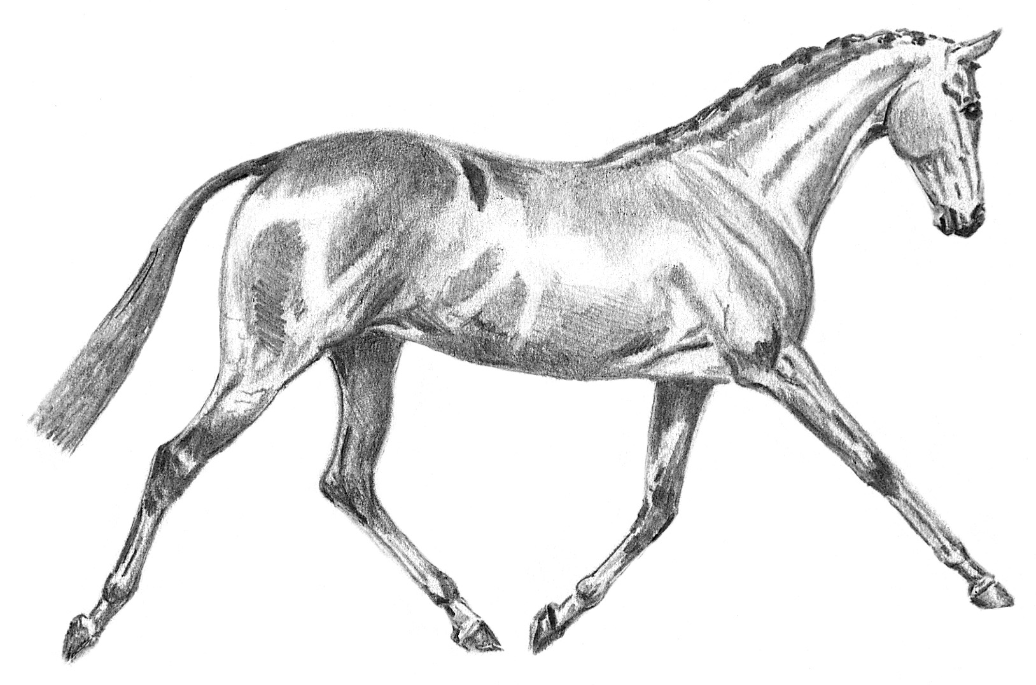

This show is run in accordance with the rules of the national pony society
Please visit the website for a full list of nps rules.www.nationalponysociety.org.uk
NATIONAL PONY SOCIETY
Area 27 north Wales

ON 25TH APRIL 2009 AT BRYN DERW FARM BRYN REFAIL CAERNARFON LL55 3PD
COMMENCING @ 9.00AM

Directions
Leave A55 at junction 11 at mini round about turn left onto B4366 signposted Bethal. Continue until next roundabout, at the Tea Pot Tea House turn left onto B4547. Continue until you pass the Garage on your left, as you go down the hill the, there are red lines on the road, venue is on the left, turn into the farm. Lorries straight on, cars and trailers turn to the left. It will be sign posted.

STALLION CLASSES NOT BEFORE 2.00PM

Open to all showing enthusiasts’ members and non-members all are welcome

Ring 1
9.00am
Riding Ponies Judge Mr. P Whitlow
1. Yearling colt, filly or gelding 12.2hh & under
2. 2/3 year old colt, filly or gelding, 12.2hh & under
3. Yearling colt, filly or gelding, exceeding 12.2hh, not exceeding 14.2hh
4. 2/3 year old colt, filly or gelding, exceeding 12.2hh, not exceeding 14.2hh
Championship 1

Hunter Ponies Judge Miss. A. Mitchell
5. Yearling colt, filly or gelding 13hh and under.
6. 2/3 year old colt, filly or gelding 13hh & under
7. Yearling colt, filly or gelding exceeding 13hh, not exceeding 15hh
8. 2/3 year old colt, filly or gelding exceeding 13hh, not exceeding 15hh
Championship 2

Mountain and Moorlands Judge Mr. Avery
(Not before completion of coloured classes)
9. Yearling colt, filly or gelding, Dartmoor, Exmoor & Shetland
10. Yearling, colt, filly or gelding, Welsh section A & B
11. Yearling colt, filly or gelding, Dales, Fell or Highland.
12. Yearling colt, filly or gelding, New Forest & Connemara
13. Yearling colt, filly or gelding, Welsh section C & D.
14. 2/3 year old colt, filly or gelding, Dartmoor, Exmoor & Shetland
15. 2/3 year old colt, filly or gelding, Welsh sec A & B

Ring 2
STALLION CLASSES Not before 2.00pm
Shetlands Judge Mr. Kay
73. Minature Shetland
74. Standard Shetland

Coloureds Judge Mr. Avery
75. Junior 6 years and under
76. Senior over 6 years

Part bred Welsh Judge Mrs. Sells
77. Junior 6 years and under
78. Senior over 6 years

Part bred Arab Judge Mr. Whitlow
79. Junior 6 years and under
80. Senior over 6 years

Welsh section C Judge Mr. Richardson
81. Junior 6 years and under
82. Senior over 6 years

Welsh section D Judge Mr. Richardson
83. Junior 6 years and under
84. Senior over 6 years

Supreme Stallion Judge Mrs. Sue Rogers
Prize £50 donated by Mrs. N.J. Gawley.

STALLION CLASSES Not Before 2.00pm
Ring 1
Riding ponies Judge Mr. Whitlow
61. 12.2hh and under
62. over 12.2hh

Hunter ponies Judge Miss. Mitchell
63. 13hh and under
64. over 13.hh

M & M Judge Mr. Avery
65 13.2hh and under
66. Exceeding 13.2hh – 15hh

Pure bred Arab Judge Miss. Mitchell
67. Junior, 6 years and under
68. Senior over 6 years.

Welsh section A Judge Mrs. Sells
69. Junior 6 years and under
70. Senior over 6 years

Welsh section B Judge Mrs. Sells
71. Junior 6 years and under
72. Senior over 6 years

Ring 1 continued
16. 2/3 year old, colt, filly or gelding, Dales, Fell & Highland.
17. 2/3 year old, colt, filly or gelding, New Forest & Connemara
18. 2/3 year old, colt, filly or gelding, Welsh sec C & D
Championship 3

Ring 2
9.00am
Shetlands Judge Mr Kay
(Special rosettes for 34’’ & under – miniatures)
19. Yearling, colt, filly or gelding
20. 2year old, colt, filly or gelding
21: 3 year old, colt, filly or gelding.
Championship 4
Coloureds Judge Mr. Avery
22. Yearling, colt, filly or gelding.
23. 2 year old, colt, filly or gelding
24. 3 year old, colt, filly or gelding
Championship 5

Anglo & Part Bred Arabs Judge Mr. Whitlow.
25. Yearling, colt, filly or gelding
26. 2 year old, colt, filly or gelding
27. 3 year old, colt, filly or gelding
Championship 6

Arabs Pure Bred Judge Miss. A. Mitchell
28. Yearling, colt, filly or gelding
29. 2 year old, colt, filly or gelding
30. 3 year old, colt, filly or gelding
Championship 7
Ring 2 continued
Part Bred Welsh Judge Mrs. G Sells
31. Yearling colt
32. Yearling filly or gelding
33. 2 year old colt
34. 2 year old filly or gelding
35. 3 year old colt
36. 3 year old filly or gelding
Championship 8

Ring 3
9.00am

Welsh Section A Judge Mrs. G Sells
37. Yearling colt
38. Yearling filly or gelding
39. 2 year old colt
40. 2 year old filly or gelding
41. 3 year old colt
42. 3 year old filly or gelding
Championship 9

Welsh Section B Judge Mrs. G Sells
43. Yearling colt
44. Yearling filly or gelding
45. 2 year old colt
46. 2 year old filly or gelding
47. 3 year old colt
48. 3 year old filly or gelding
Championship 10

Welsh Section C Judge Mr. Richards
49. Yearling colt
50. Yearling filly or gelding
51. 2 year old colt
52. 2 year old filly or gelding
53. 3 year old colt
54. 3 year old filly or gelding
Championship 11

Welsh Section D Judge Mr. Richards
55. Yearling colt
56. Yearling filly or gelding
57. 2 year old colt
58. 2 year old filly or gelding
59. 3 year old colt
60. 3 year old filly or gelding
Championship 12

Supreme Championship Judge Mrs Sue Rogers
All Champions from Championships 1 – 12 to compete for the Supreme Championship and Reserve
Prize of £50 donated to the Supreme Youngstock by
Mrs. Rickard. Wellbank Stud

