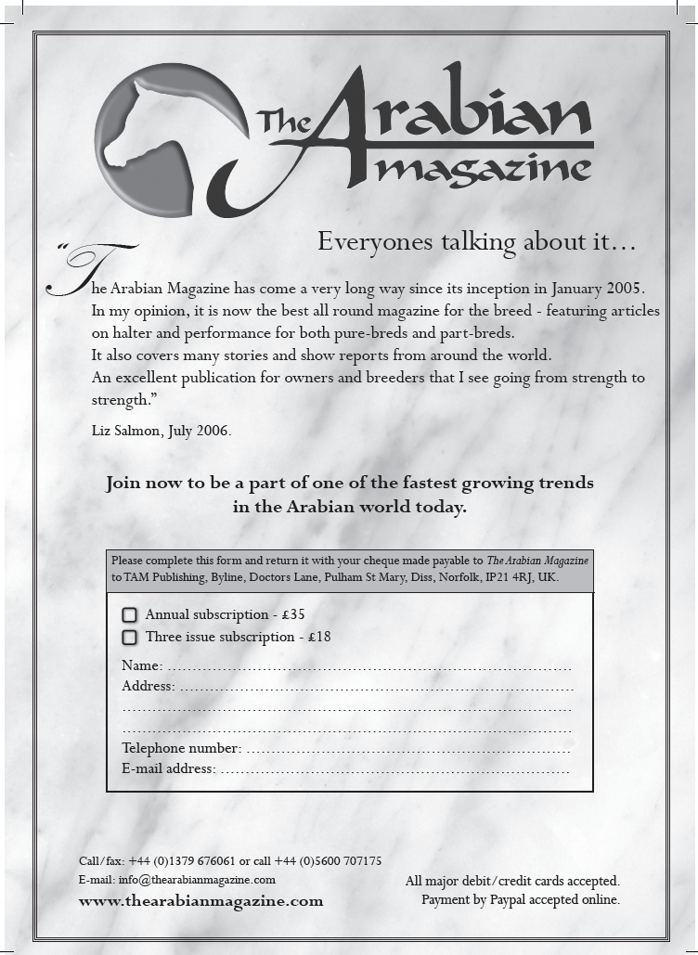

HOME COUNTIES NORTH
REGIONAL GROUP OF THE ARAB HORSE SOCIETY
OPEN ARAB ‘C’ SHOW
With Amateur Classes
Schedule
Entries Close 5th May 2009

SATURDAY 6 AND SUNDAY 7 JUNE 2009
TOWERLANDS PARKLANDS
Panfield Road, Braintree, Essex
Affiliated to
The Arab Horse Society
ECAHO
HOYs / Cherif
Photographer - Refreshments
● Photographer ● Refreshments ●

